**PORTFOLIO**

**Sanjana Sham Sunder Bharadwaj**

**Chemical Engineer**

**(B.E Chemical Engineering)**

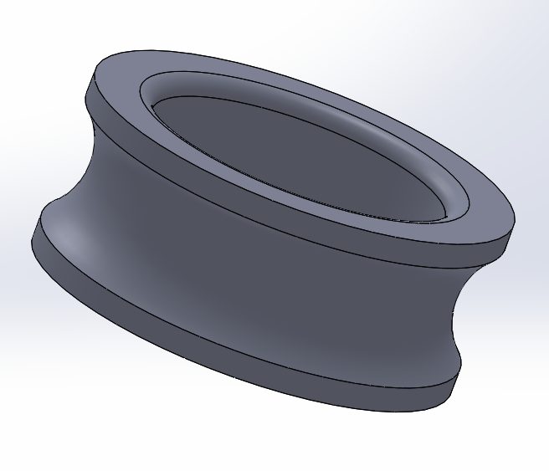 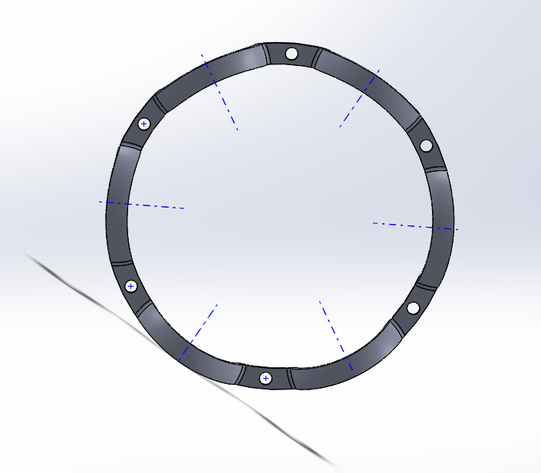

As a Chemical Engineering Undergraduate, I suddenly sparked interest in design as I was working on an individual project related to mixing industry. I had to design several impellers and gear assemblies which replicated the impeller’s motion in a mixing vessel. I performed several motion studies and particle tracing to understand the motion of different gear assemblies.

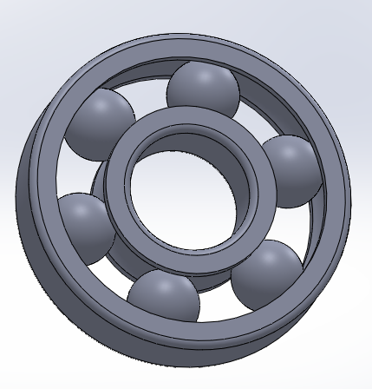

I started designing in solidworks by following a few tutorials online to create a ball bearing assembly as I have shown here.

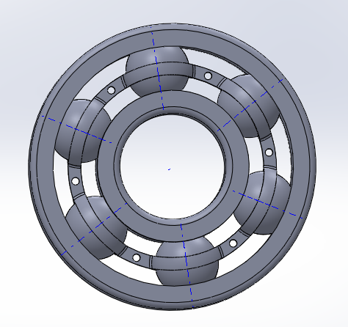

The mates between the parts were done in such a way that, when the outer casing is rotated, this model imitates a real ball bearing.

**Diagonally Folded Impeller**

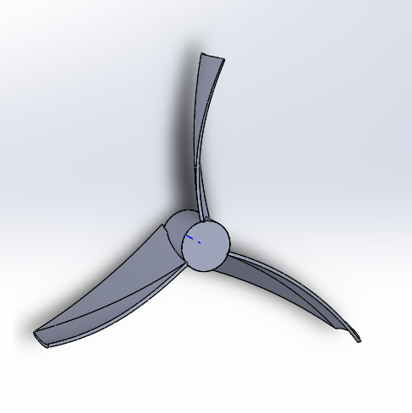 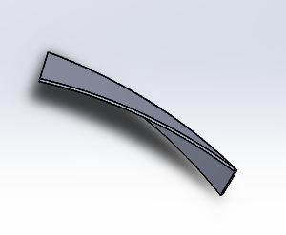

Diagonally folded impeller with 3 blades

The diagonally folded impeller was created by first creating the blades. The sketch of the blade is a simple rectangle which was then extruded, flexed and bent to form the correct angle of the blades.

The blades were then shaved to fit the centre of the impeller without any gaps. Any small gaps or errors would lead to difficulty in meshing for simulation.

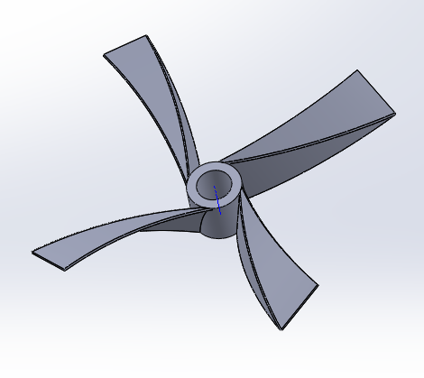

*Diagonally Folded Impeller with 4 blades*

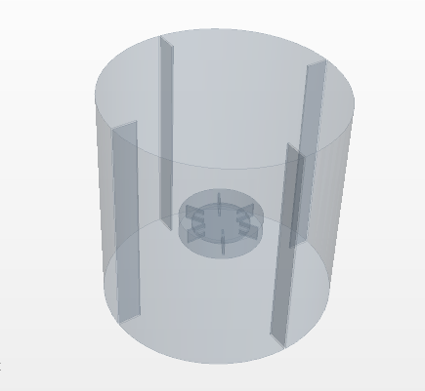 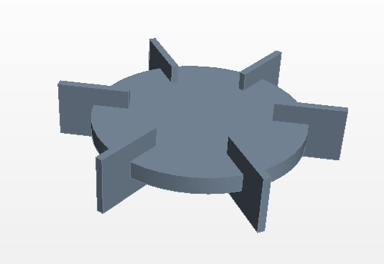

Rushton Turbine was designed in STAR CCM+. This impeller was placed in a cylinder with baffles to analyse the mixing performance of Rushton turbine. impellers.

**Apocentric and Pericentric paddles**

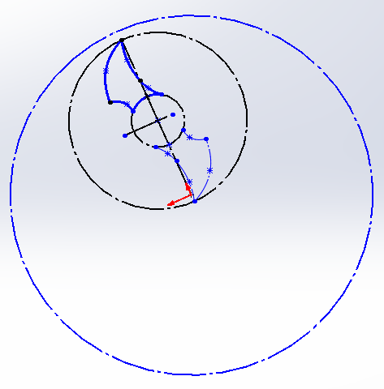 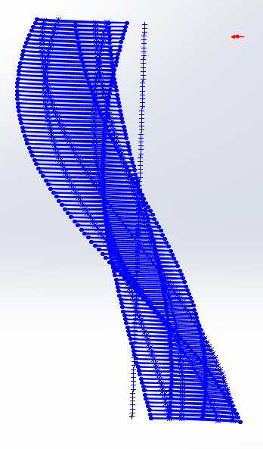

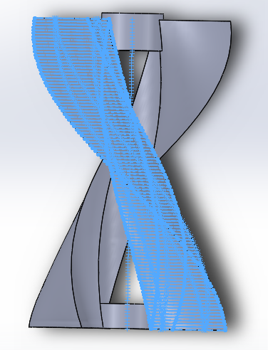

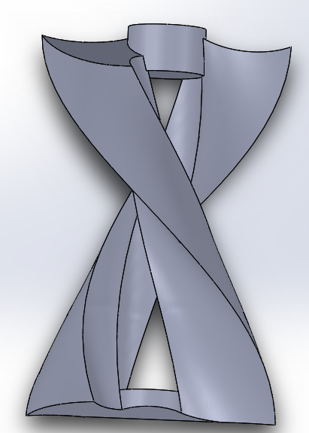

Apocentric Paddles- They were created by duplicating and mirroring the initial sketch. Then the entire sketch was lofted to create the 3D image

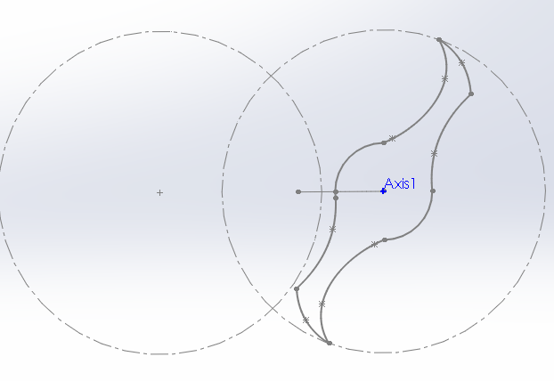 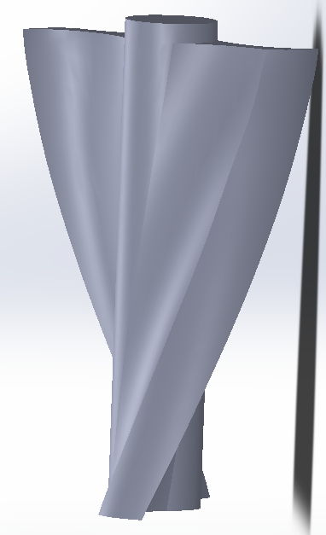

Pericentric Paddles were created by extruding and twisting the sketch to a given angle.

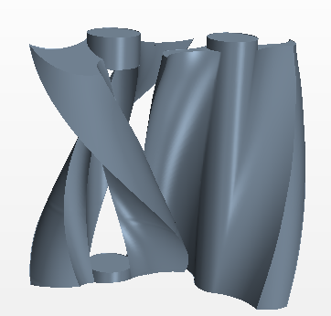

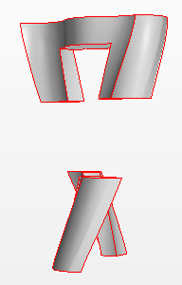 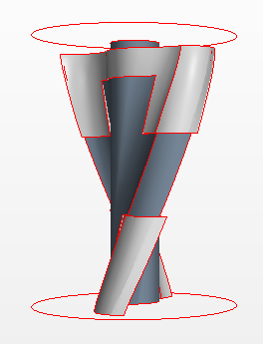

Additional geometries were created around the paddles for refined meshing during simulation.

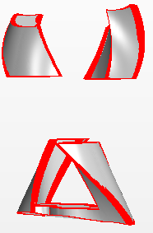 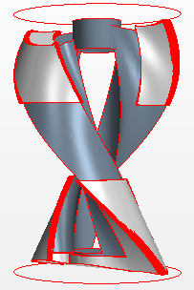

Gears

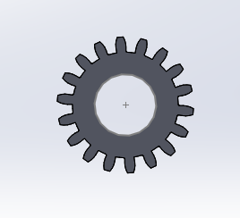

Internal and external gears were designed and assembled with appropriate mates to give rise to planetary motion when motor was placed on sun gear

Spur Gear

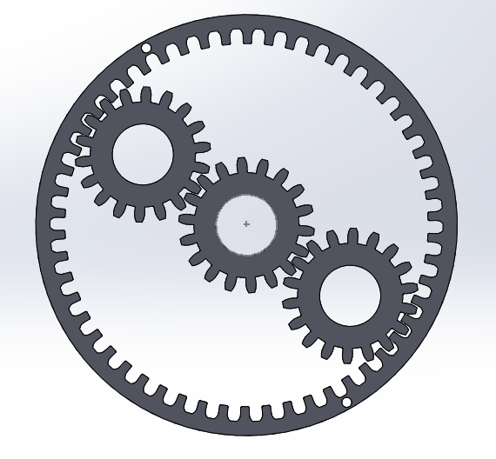

*Planetary Gear System*

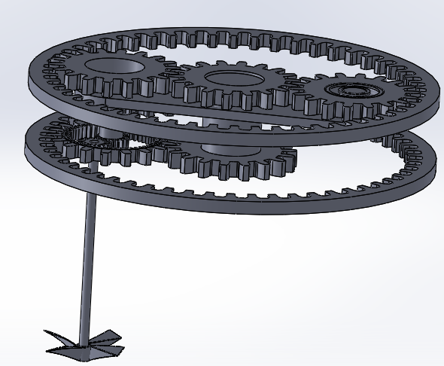

A Unique epicyclic gear system was assembled along with the impeller to find the path traced by the tip of the impeller in a mixing tank

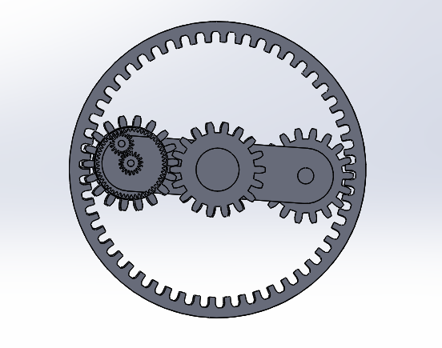

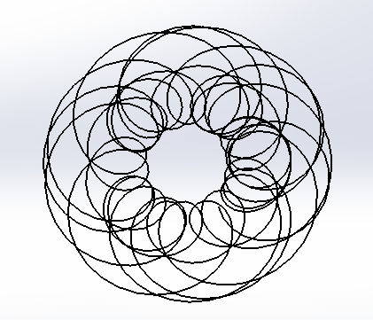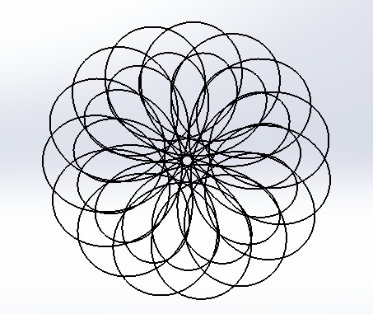

Path Traced by tip of impeller for different gear ratios of sun, planet and outer ring.

